Case 10-MEX-Veracruz-Figure-400-800 CE

Handsome buff brown terra cotta of a sitting male shaman with slit eyes that suggest a trance state. This figure wears a disc-shaped headdress with a topknot and a chin strap, a cape-mantle with incised punched texture that emulates fur that has a broad rolled trim. A loincloth is secured with a waist belt.  A third support leg that suggests a seat incorporates a whistle feature. The head, chest and limbs are painted black. This is a striking piece of great eye appeal. The figure is intact as pictured but there is partial loss to part of topknot and the loincloth.

Height: 6-3/4 in. (17 cm). EX Zeus Gallery with C.O.A.

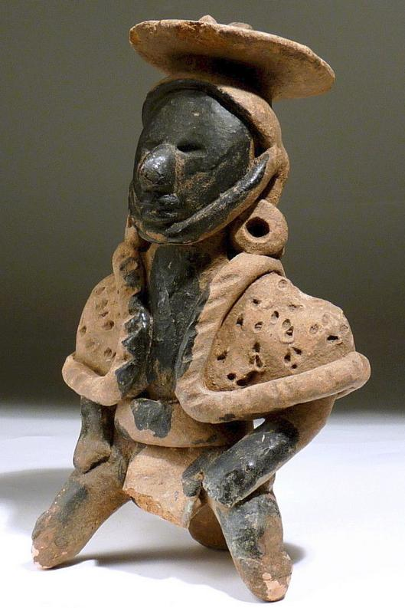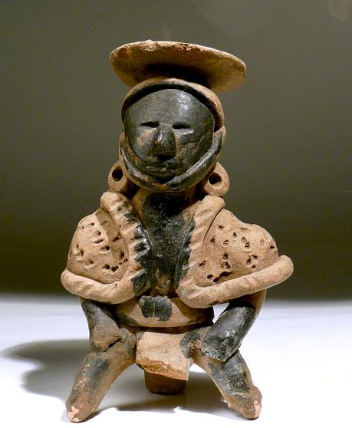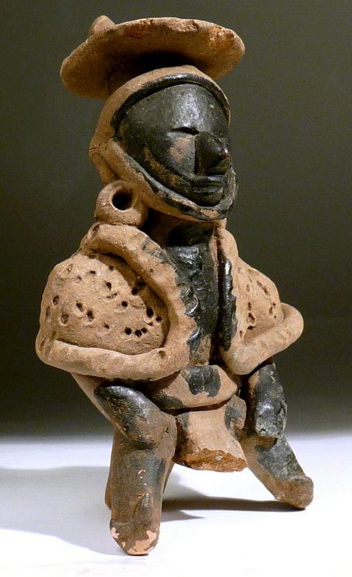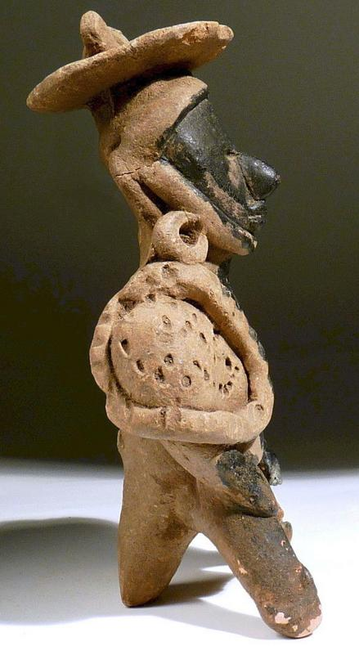

Sold by [zeus_gallery](http://myworld.ebay.com/zeus_gallery) ( [3234](http://feedback.ebay.com/ws/eBayISAPI.dll?ViewFeedback&userid=zeus_gallery) )

### Delivery package 1 of 1

Estimated delivery Monday, Dec 21, 2015

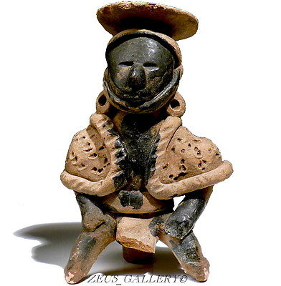

#### [Pre Columbian Pottery PRIEST Figure VERACRUZ RARE Black Paint Whistle 6-3/4"Tall](http://www.ebay.com/itm/301819145958)

|  |  |
| --- | --- |
| Item price | $450.00 |
| Quantity | 1 |
| Item number | 301819145958 |
| Shipping service | USPS First Class Package |

## Shipping address

Ralph J Coffman Jr

149 Atlantic Ave

Swampscott MA 01907-2427

United States Order total

|  |  |
| --- | --- |
| Subtotal | $450.00 |
| Shipping | Free |

**Total**

$450.00